# Media Analysis - No need to demonize ChatGPT but AI regulation is a must

## Short Summary

The article highlights ChatGPT's integration into Saudi Arabian journalism, noting its transformative impact and challenges such as job displacement concerns, with calls for responsible regulation.

## Summary

1. **ChatGPT as an AI tool**: Developed by OpenAI, ChatGPT is a large language model capable of understanding and generating human-like text based on the input it receives. It can write essays, articles, research papers, reports, poetry, explain complex scientific concepts in simple language, and even generate recipes. 2. **Impact on Journalism**: In Saudi Arabia, ChatGPT is being used to enhance news production and consumption. It has the potential to revolutionize journalism by automating repetitive tasks such as drafting headlines or summarizing long articles, allowing human journalists to focus more on in-depth reporting and analysis. 3. **Opportunities vs Risks**: The integration of ChatGPT into journalism presents both opportunities and risks. Opportunities include increased efficiency, cost reduction, and the ability to generate content at a faster pace. However, risks involve job displacement for human journalists who may struggle with the automation, potential loss of editorial judgment, and ethical concerns surrounding AI-generated news. 4. **Educational Impact**: The advent of ChatGPT is causing significant shifts in education. Teachers are exploring new methods to detect AI-generated text (like GPTZero) as a means to protect original work. There's a fear that human teachers might be replaced by AI, but proponents argue it could empower all learners globally by providing equal access to knowledge and resources. 5. **Threats in Specific Fields**: In medical fields, ChatGPT has passed the US Medical Licensing Examination experiments. This raises concerns about potential displacement of human doctors who may not have access to advanced AI systems for diagnosis and decision-making. However, it's noted that AI is more likely to augment rather than replace human roles in this industry. 6. **Limitations and Ethical Concerns**: Despite its capabilities, ChatGPT isn't perfect. It can make mistakes, struggles with nuanced prompts, and generates content from outdated information. While it has safeguards against producing harmful or inappropriate responses, ethical dilemmas persist regarding AI-generated art and literature. 7. **Need for Regulations**: Given the potential impacts on various professions, there's a need for regulations to ensure that AI like ChatGPT benefits humanity without causing significant job losses or societal disruption. The goal should be an 'equalizer' rather than a threat, leveraging AI's power to empower everyone.

## Question 1:

How do the media in this article frame the public discussion about ChatGPT? Are there certain **metaphors** that keep cropping up?

disruption

## Question 2:

Which role does or might the Arabic World play in the development of Artificial Intelligence? Answer with 'Not mentioned' if not applicable.

Not mentioned

## Question 3:

Which use cases of Artificial Intelligence are helpful for the Arabic world based on this article?

ChatGPT can aid journalism by generating news content quickly and accurately, assist in education through new teaching methods, potentially impact the medical field by augmenting human work rather than replacing doctors, and contribute to literature with its ability to write and illustrate books.

## Question 4:

What is the final message of the article that the author wants to convey? Keep your answer short and precise!

AI has the potential to revolutionize various fields, but it's crucial to manage its development responsibly to prevent job displacement and maintain societal balance.

## Sentiment

The sentiment is <0>

The article presents both positive and negative perspectives on ChatGPT's impact on journalism in Saudi Arabia, as well as its potential implications for other sectors such as education, employment, and healthcare. The sentiment towards AI is not uniformly negative; instead, it shows a balanced view that acknowledges the opportunities and challenges posed by this technology. The author raises concerns about potential threats to human work and jobs but also emphasizes the transformative power of AI in advancing education and healthcare sectors. The overall tone is cautious yet optimistic, suggesting a neutral to slightly positive sentiment towards ChatGPT and AI as a whole.

## Entities

Accord Axios Chatgpt, Seattle Public School System Quickly Ban University College Fear Ban Ineffective Raise Question Academic Freedom Busy Try Contain Chatgpt Potentially Negative Impact Education Change Mode Instruction Give Oral Exam Handwritten, New Technology Chatgpt View, Washington Post Article Write Chatgpt See Lucid Different Write Human Post Consider Experiment Journalistic Disaster, New York Times, Newsroom, Chatgpt Midjourney Ai Program

## Topic Clusters

### Cluster: AI Ethics in Arab Societies

ChatGPT, Artificial Intelligence impacts on society, Ethical concerns about AI

### Cluster: Arabic Media Coverage of ChatGPT

Introduction to ChatGPT, Comparative analysis with other AI tools, Perceptions and opinions from the Arab audience

## Word Clouds

### Wordcloud of content

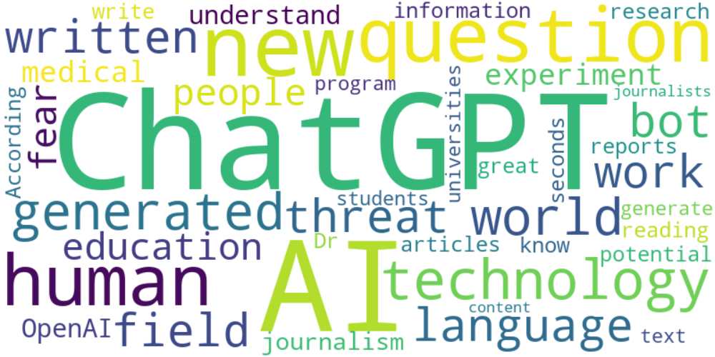

Top 10 words:

- ChatGPT: 27  
- AI: 24  
- human: 7  
- technology: 6  
- world: 5  
- generated: 5  
- field: 4  
- language: 4  
- news: 4  
- written: 4

### Wordcloud of summary

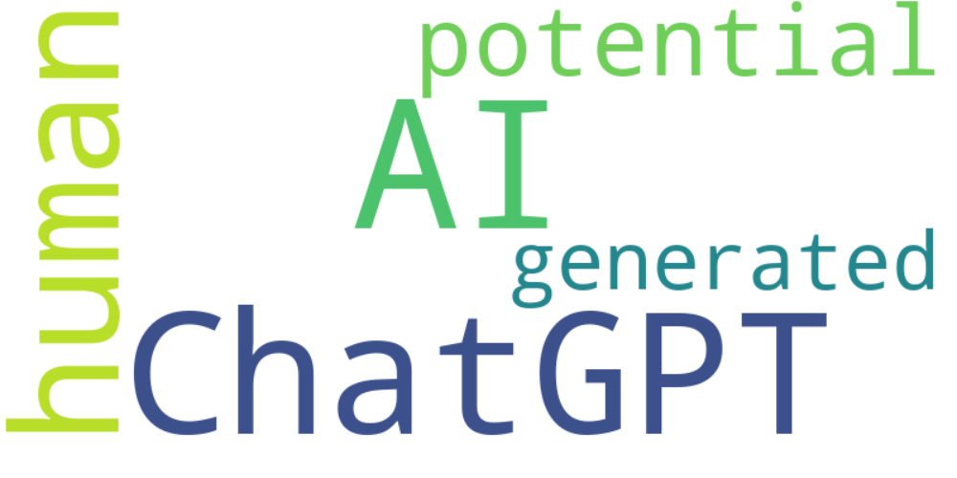

Top 10 words:

- AI: 9  
- ChatGPT: 8  
- human: 6  
- potential: 4  
- like: 3  
- generated: 3